Module 1 : Fundamentals
(1) What is SDLC?
- SDLC stands for Software Development Life Cycle. SDLC is a process used by the software industry to design, develop, and test the high quality softwares.
- Its aim to produce a high-quality software that meets or exceeds customer expectations, reaches completion within times and cost estimates.
(2) What is Software Testing?
- Software Testing is a process of evaluating a system or its component(s) with the intend to find that whether it satisfied the specific requirements or not.
- Software Testing is a process used to identify the Correctness, Completeness, and Quality of developed computer software.
(3) What is Agile Methodology?
- Agile Methodology is a collection of some principals used for developing a software.
- It is a practice that promotes continuous iteration of development and testing throughout the software development life cycle of the project.

(4) What is SRS?
- A Software Requirements Specification (SRS) is a complete description of the behavior of the system to be developed.
- It's a document that describes what the software will do and how it will be expected to perform.
(5) What is OOPS?
- Object-oriented programming (OOP) is a computer programming model that organizes software design around data, or objects, rather than functions and logic.
- An object is like a black box in which the internal details are hidden.
(6) Write basic concepts of OOPs?
The basic concepts of object-oriented programming are as follows :
- Object
- Class
- Encapsulation
- Inheritance
- Polymorphism
- Abstraction
(7) What is Object?
- Object is the instance of the class, used to create memory for the class.
- Also to access the whole properties (member function and data member) of an class except private.
Syntax : classname objectname = new classname();
(8) What is Class?
- Class is a collection of data members (variables) and member functions (process,methods) with its behaviors.
- A class is a blueprint for declaring and creating objects.
Syntax : class classname
{
variables(data members)
methods(member functions)
}
(9) What is Encapsulation?
- Encapsulation helps to bind the data and functions together that manipulate the data.
- Encapsulation of data leads to the OOP concept of data hiding and keeps them safe from outside attention. Example : Calculator.
(10) What is Inheritance?
- Inheritance is a feature or a process in which, new classes are created from the existing classes. The new class created is called “derived class” or “child class” and the existing class is known as the “base class” or “parent class”. The derived class now is said to be inherited from the base class.
- There are mainly 5 types of Inheritance :
- Single
- Multilevel
- Hierarchical
- Multiple
- Hybrid
(11) What is Polymorphism?
- Polymorphism allows us to perform a single action in different ways. In other words, polymorphism allows us to define one interface and have multiple implementations. The word “poly” means many and “morphs” means forms, So it means many forms.
- There are mainly 2 types of polymorphism :
- Compile-time Polymorphism
Compile-time Polymorphism is also known as Method Overloading. When there are multiple functions with the same name but different parameters then these functions are said to be overloaded.
- Runtime Polymorphism is also known as Method overriding, and it occurs when a derived class has a definition for one of the member functions of the base class. That base function is said to be overridden. In other words, the whole signature of the method should be same in super class as well as in sub class but its behavior (body part) are different.

(12) Draw Usercase on online book shopping.
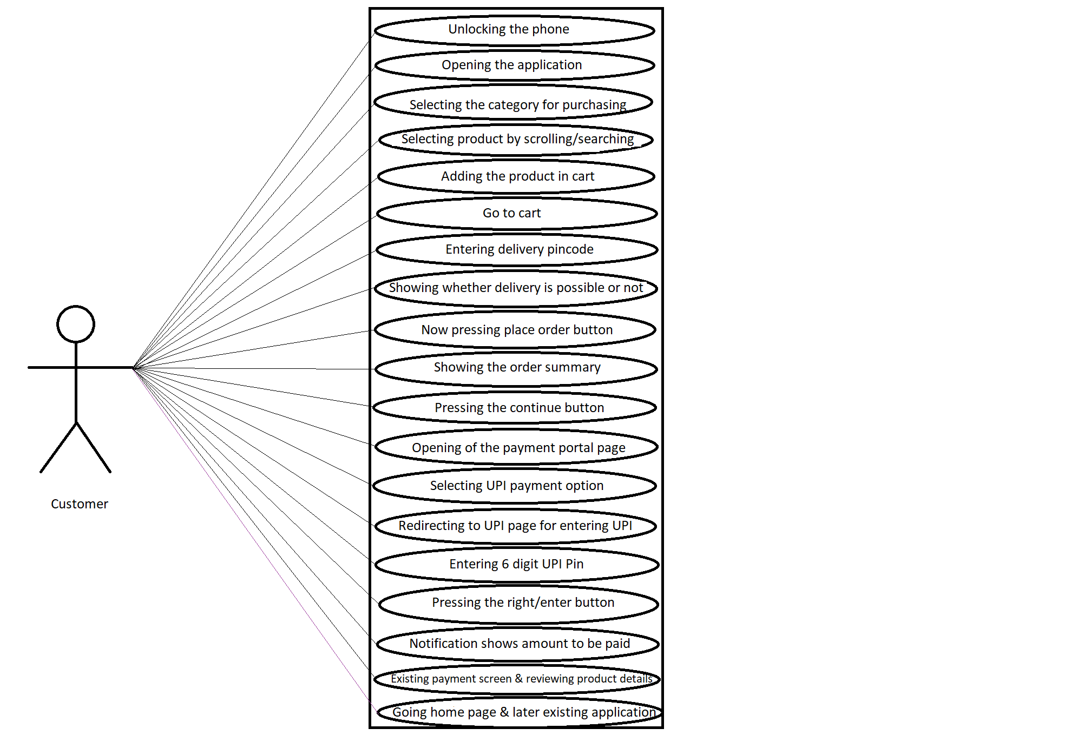

(13) Draw Usercase on online bill payment system.
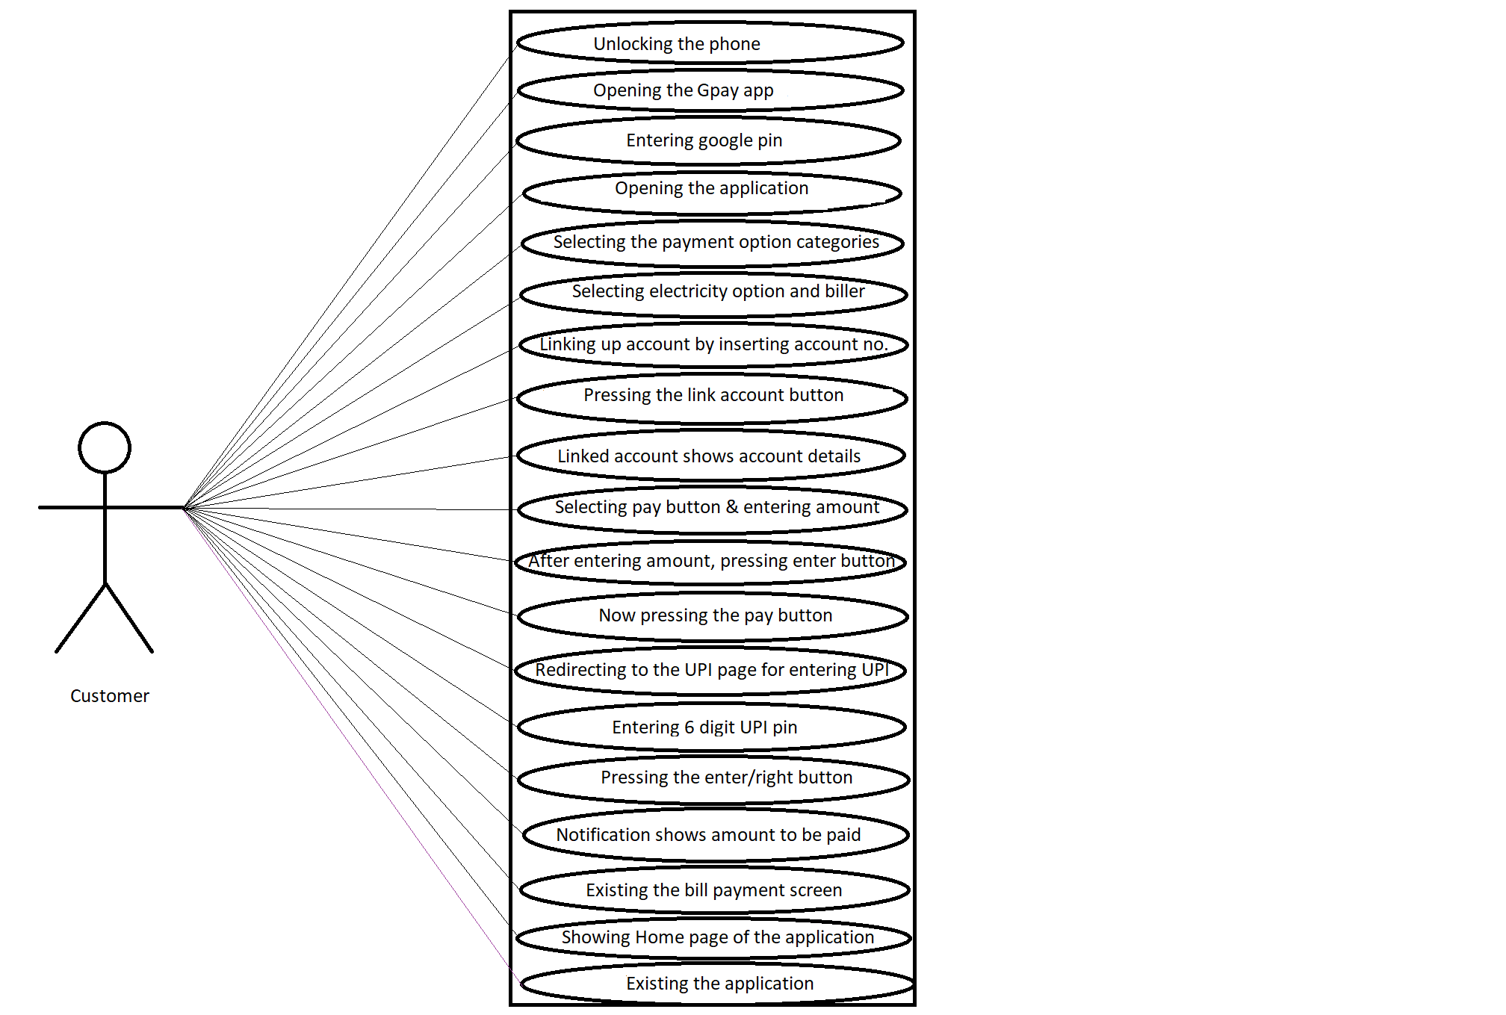

(14) Write SDLC phases with basic introduction?
- There are 6 SDLC phases and are follows:
- Requirement Collection/Gathering --> Establishing customer needs by communicating. During this phase, all the relevant information is collected from the customer to develop a product as per their expectation. Any ambiguities must be resolved in this phase only. Here 3 types of problems can arise :
(a) Lack of clarity
(b) Requirements confusion
(c) Requirements amalgamation
- Analysis --> An analysis is done to check the feasibility of the development of a product. In case of any ambiguity, a call is set up for further discussion. This represents the "WHAT" phase, that is, requirements documentaries to capture the requirements from the customer's perspective by defining goal. Also represents the "HOW" phase.
- Design --> In this phase, the requirement gathered in the SRS document is used as an input and software architecture that is used for implementing system development is derived.
- Implementation --> Implementation/Coding starts once the developer gets the Design document. The Software design is translated into source code. All the components of the software are implemented in this phase.
- Testing --> Testing starts once the coding is complete and the modules are released for testing. In this phase, the developed software is tested thoroughly and any defects found are assigned to developers to get them fixed.
- Maintenance --> After the deployment of a product on the production environment, maintenance of the product i.e. if any issue comes up and needs to be fixed or any enhancement is to be done is taken care by the developers. Here 3 types of maintenance presents and are follows :
(a) Corrective Maintenance
(b) Adaptive Maintenance
(c) Perfective Maintenance
(15) Explain phases of the Waterfall Model?
In this model, the outcome of one phase is the input for the next phase. Development of the next phase starts only when the previous phase is complete.
- First, Requirement gathering and analysis is done. Once the requirement is freeze then only the System Design can start.
- Herein, the SRS document created is the output for the Requirement phase and it acts as an input for the System Design.
- In System Design Software architecture and Design, documents which act as an input for the next phase are created i.e. Implementation and coding.
- In the Implementation phase, coding is done and the software developed is the input for the next phase i.e. testing.
- In the testing phase, the developed code is tested thoroughly to detect the defects in the software and the developed code is moved into production after the sign off is given by the customer.
- Any issues in the production environment are resolved by the developers which come under maintenance.
(16) Write phases of Spiral Model?
Spiral Model has 4 phases and are follows :
- Planning --> The planning phase includes requirement gathering wherein all the required information is gathered from the customer and is documented.
- Risk Analysis --> In this phase, the best solution is selected for the risks involved and analysis is done by building the prototype
- Engineering --> Once the risk analysis is done, coding and testing are done here.
- Customer Evaluation --> Customer evaluates the developed system and plans for the next iteration.
(17) Write Agile Manifesto Principles?
The four core values of Agile software development as stated by the Agile Manifesto are:
- Individuals and Interactions Over Processes and Tools
- Working Software Over Comprehensive Documentation
- Customer Collaboration Over Contract Negotiation
- Responding to Change Over Following a Plan
The Twelve Agile Manifesto Principles are :
- Customer satisfaction through early and continuous software delivery.
- Accommodate changing requirements throughout the development process.
- Frequent delivery of working software.
- Collaboration between the business stakeholders and developers throughout the project.
- Support, trust, and motivate the people involved.
- Enable face-to-face interactions.
- Working software is the primary measure of progress.
- Agile processes to support a consistent development pace.
- Attention to technical detail and design enhances agility.
- Simplicity.
- Self-organizing teams encourage great architectures, requirements, and designs.
- Regular reflections on how to become more effective.
(18) Explain working methodology of agile model and also write pros and cons?
- Agile Model is a combination of the Iterative and incremental model. This model focuses more on flexibility while developing a product rather than on the requirement.
- In Agile, a product is broken into small incremental builds. It is not developed as a complete product in one go. Each build increments in terms of features. The next build is built on previous functionality.
- In Agile, iterations are termed as sprints. Each sprint lasts for 2-4 weeks. At the end of each sprint, the product owner verifies the product and after his approval, it is delivered to the customer.
- Customer feedback is taken for improvement and his suggestions and enhancement are worked on in the next sprint. Testing is done in each sprint to minimize the risk of any failures.
Pros -->
- It allows more flexibility to adapt to the changes.
- The new feature can be added easily.
- Customer satisfaction as the feedback and suggestions are taken at every stage.
Cons -->
- Lack of documentation.
- Agile needs experienced and highly skilled resources.
- If a customer is not clear about how exactly they want the product to be, then the project would fail.
(19) Draw Usercase on online shopping product using COD.
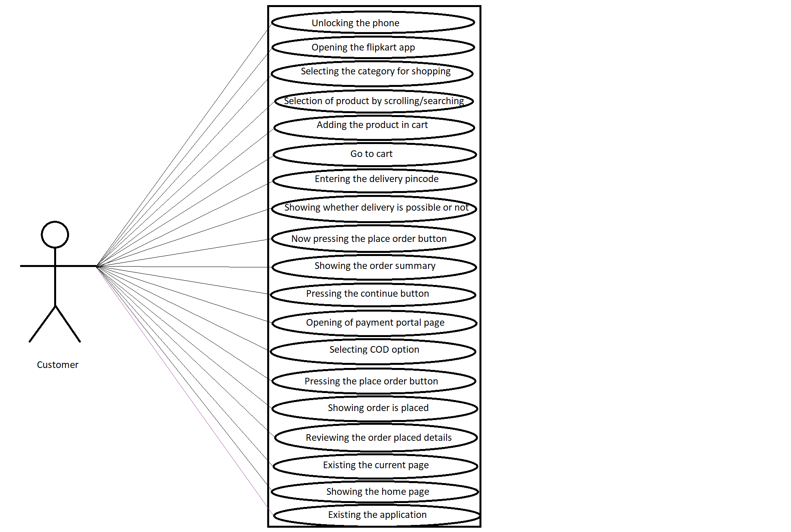

(20) Draw Usercase on online shopping product using payment gateway.

